**MODULE: 6 (Bootstrap Basic & Advance)**

**1.What are the advantages of Bootstrap?**

**Ans.** Bootstrap is an open-source CSS framework designed to come up with mobile-friendly, responsive front-end web development.

You can efficiently blend its ready-made coding blocks, CSS-Less functionality, and cross-browser compatibility to save tedious hours of coding.

**2.** **What is a Bootstrap Container, and how does it work?**

**Ans. Bootstrap Containers** are the most basic layout element in Bootstrap. Bootstrap **Containers**are very essential and basic building blocks of bootstrap that wrap a page’s content. It’s responsible for setting and aligning content within it according to viewport or given device. Containers are defined within the container class **(.container)**.

**Containers are used for many purposes such as –**

* It requires use with the default grid system.
* To provide responsive fixed behavior of any web project.

Basically, there are three types of container classes available in bootstrap:

1. Default-Container(container)
2. Responsive-Container(along with sm, md, lg, xl, xxl)
3. Fluid-Container(container-fluid)

**3.What are the default Bootstrap text settings?**

**Ans.** Bootstrap 4 uses a **default font-size of 16px, and its line-height is 1.5**. The default font-family is "Helvetica Neue", Helvetica, Arial, sans-serif. In addition, all <p> elements have margin-top: 0 and margin-bottom: 1rem (16px by default).

**4.What do you know about the Bootstrap Grid System?**

## **Bootstrap Grid System**

1. [Introduction and Installation](https://www.geeksforgeeks.org/beginning-bootstrap-part-1/)
2. [Buttons, Glyphicons, Tables](https://www.geeksforgeeks.org/bootstrap-part-3/)
3. [Vertical Forms, Horizontal Forms, Inline Forms](https://www.geeksforgeeks.org/bootstrap-part-4/)
4. [DropDowns and Responsive Tabs](https://www.geeksforgeeks.org/bootstrap-part-5/)

**Grid System:** Bootstrap Grid System allows up to 12 columns across the page. You can use each of them individually or merge them together for wider columns. You can use all combinations of values summing up to 12. You can use 12 columns each of width 1, or use 4 columns each of width 3 or any other combination.[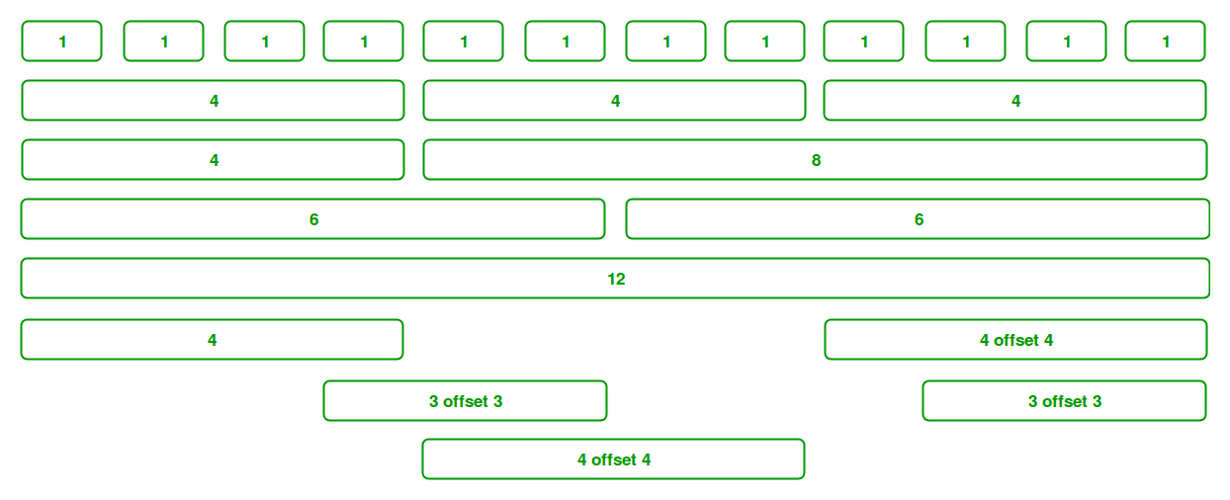](https://media.geeksforgeeks.org/wp-content/uploads/Bootstrap-part-2.png)

**5.What is the difference between Bootstrap 4 and Bootstrap 5**

**Ans.**

| **BASIS OF** | **BOOTSTRAP 4** | **BOOTSTRAP 5** |
| --- | --- | --- |
| **Grid System** | It has 5 tier (xs, sm, md, lg, xl). | It has 6 tier (xs, sm, md, lg, xl, xxl). |
| **Color** | It has limited colors. | Extra colors added with the looks, A card improved color palette. there are various shades available to choose. |
| **Jquery** | It has jquery and all related plugins. | Jquery is removed and switched to vanilla JS with some working plugins |
| **Internet Explorer** | Bootstrap 4 supports both IE 10 and 11. | Bootstrap 5 doesn’t support IE 10 and 11. |
| **Form elements** | Radio buttons, checkboxes have different look in different OS and browsers. The form uses whatever default browsers provide. | The look of form elements will not change, on different OS or browser. The forms can be customized and form controls can be added, they would not depend on browser. |

**6.What is a Button Group, and what is the class for a basic Button Group?**

**Ans.**“Button Groups” in Bootstrap is a class of name “btn-group” which is used to create series of buttons in groups (without spaces) vertically or horizontally.

basic syntax

<div class="btn-group">

<button type="button" class="btn">Click</button>

</div>

**Adding Styles on Buttons:**Bootstrap allows you to add styles to your buttons using the following classes:

* .btn-default
* .btn-primary
* .btn-success
* .btn-info
* .btn-warning
* .btn-danger
* .btn-link

**Example:**

<!DOCTYPE html>

<html lang="en">

<head>

    <meta charset="UTF-8">

    <meta http-equiv="X-UA-Compatible" content="IE=edge">

    <meta name="viewport" content="width=device-width, initial-scale=1.0">

    <title>Document</title>

    <link rel="stylesheet" href=

"https://maxcdn.bootstrapcdn.com/bootstrap/3.3.6/css/bootstrap.min.css">

    <script src=

"https://ajax.googleapis.com/ajax/libs/jquery/1.12.0/jquery.min.js">

    </script>

    <script src=

"https://maxcdn.bootstrapcdn.com/bootstrap/3.3.6/js/bootstrap.min.js">

    </script>

</head>

<body>

    <div class="btn-group">

        <button type="button" class="btn btn-danger">Click</button>

        <button type="button" class="btn btn-warning">Click</button>

        <button type="button" class="btn btn-success">Click</button>

    </div>

</body>

</html>

**Output:-**



**7.How can you use Bootstrap to make thumbnails?**

**Ans.** [Bootstrap](https://www.geeksforgeeks.org/bootstrap-tutorials/)helps web developers to create thumbnails that are used to show linked images in grids with the pre-defined classes which help to reduce codes length. Thumbnails are created to provide a quick preview of images with small images.

**Example 1:**The following example shows the creation of thumbnails images.

<!DOCTYPE html>

<html lang="en">

<head>

    <title>Thumbnail images</title>

    <link

    rel="stylesheet"

    href=

"http://maxcdn.bootstrapcdn.com/bootstrap/3.3.6/css/bootstrap.min.css"/>

    <script src=

"https://ajax.googleapis.com/ajax/libs/jquery/1.12.0/jquery.min.js">

    </script>

    <script src=

"http://maxcdn.bootstrapcdn.com/bootstrap/3.3.6/js/bootstrap.min.js">

    </script>

</head>

<body>

    <h3 style="color: green">Bootstrap thumbnails</h3>

    <div class="row">

    <div class="col-sm-6 col-md-3">

        <a href="#" class="thumbnail">

        <img src="https://www.nato.int/nato_static_fl2014/assets/pictures/images_mfu/2020/6/stock/200612-dsg-workshop.jpg"

            style="height: 100px; width: 100px"/>

        </a>

    </div>

    <div class="col-sm-6 col-md-3">

        <a href="#" class="thumbnail">

        <img src="https://blog.vantagecircle.com/content/images/2020/08/technology-in-the-workplace.png"

            style="height: 100px; width: 100px"/>

        </a>

    </div>

    <div class="col-sm-6 col-md-3">

        <a href="#" class="thumbnail">

        <img src="https://encrypted-tbn0.gstatic.com/images?q=tbn:ANd9GcSAGEYGzHea6VYaypGpb_le6fKkVjeVKR01mA&usqp=CAU"

            style="height: 100px; width: 100px"/>

        </a>

    </div>

    <div class="col-sm-6 col-md-3">

        <a href="#" class="thumbnail">

        <img src="https://encrypted-tbn0.gstatic.com/images?q=tbn:ANd9GcQpQQKuJAtMkiUzoRYYkJ530mDRuOhXDaDQQTyd55Fgq17cT_bZmsu-EPUfMxhLbZ51OKU&usqp=CAU"

            style="height: 100px; width: 100px"/>

        </a>

    </div>

    </div>

</body>

</html>

**Output:-**

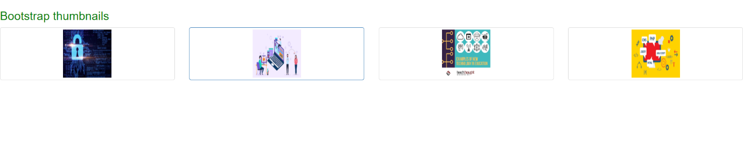

**8.In Bootstrap 4, what is flexbox?**

**Ans.** flex box is used to control the layout and alignment specification of Bootstrap 4 components. This box makes it easier to design flexible responsive layout structures without using float or positioning attributes.

<! DOCTYPE html>

<html lang="en">

<head>

  <title> Bootstrap 4 vertical Flex Box Example </title>

  <meta charset="utf-8">

  <meta name="viewport" content="width=device-width, initial-scale=1">

  <link rel="stylesheet" href="https://maxcdn.bootstrapcdn.com/bootstrap/4.5.2/css/bootstrap.min.css">

  <script src="https://ajax.googleapis.com/ajax/libs/jquery/3.5.1/jquery.min.js"> </script>

  <script src="https://cdnjs.cloudflare.com/ajax/libs/popper.js/1.16.0/umd/popper.min.js"> </script>

  <script src="https://maxcdn.bootstrapcdn.com/bootstrap/4.5.2/js/bootstrap.min.js"> </script>

</head>

<style>

h2 {

  position: relative;

  padding: 10;

  margin: 10;

  font-family: "Raleway", sans-serif;

  font-weight: 300;

  font-size: 40px;

  color: white;

  text-align: center;

  -webkit-transition: all 0.4s ease 0s;

  -o-transition: all 0.4s ease 0s;

  transition: all 0.4s ease 0s;

}

body {

    background-size: 400% 400%;

           margin: 2rem;

background: linear-gradient(-45deg, #ee7752, #e73c7e, #23a6d5, #23d5ab);

    animation: gradient 15s ease infinite;

    height: 100vh;

}

@keyframes gradient {

    0% {

        background-position: 0% 50%;

    }

    50% {

        background-position: 100% 50%;

    }

    100% {

        background-position: 0% 50%;

    }

}

</style>

<body>

<div class="container mt-3">

  <h2> Bootstrap 4 Vertical Direction flexbox </h2>

  <p> Use .flex-column-reverse to reverse the vertical direction: </p>

  <div class="d-flex flex-column-reverse">

    <div class="p-2 bg-info"> Flex item 1 </div>

    <div class="p-2 bg-warning"> Flex item 2 </div>

    <div class="p-2 bg-primary"> Flex item 3 </div>

  </div>

</div>

</body>

</html>

**Output:-**

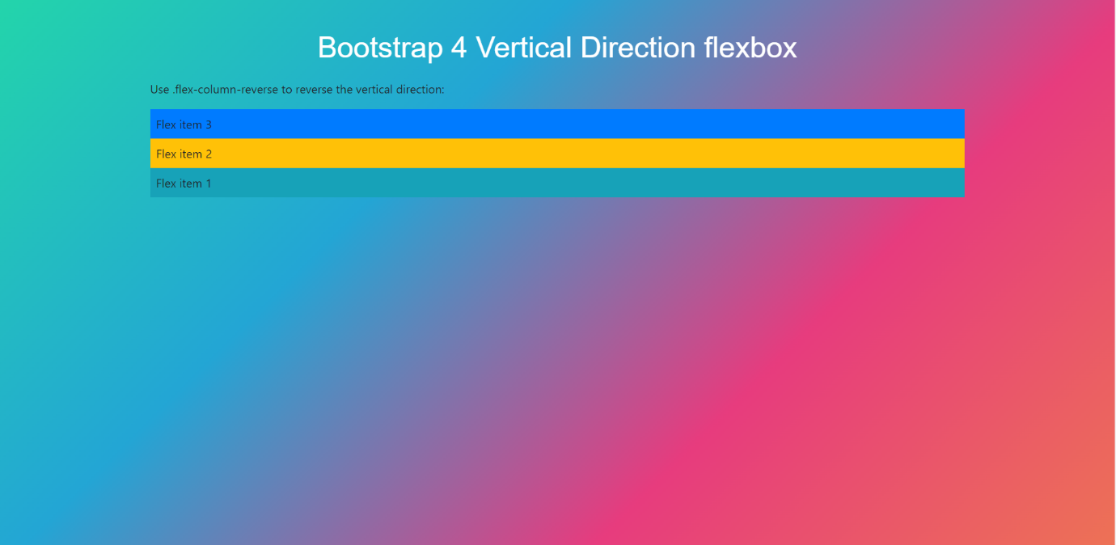

**9.How can one create an alert in Bootstrap?**

**Ans.**

<!DOCTYPE html>

<html lang="en">

<head>

    <meta http-equiv="Content-Type"

        content="text/html; charset=utf-8" />

    <title>Buttons and alerts</title>

    <link href=

"https://maxcdn.bootstrapcdn.com/bootstrap/3.1.1/css/bootstrap.min.css"

        rel="stylesheet">

    <script src=

"https://ajax.googleapis.com/ajax/libs/jquery/1.11.0/jquery.min.js">

    </script>

    <script src=

"https://netdna.bootstrapcdn.com/twitter-bootstrap/2.0.4/js/bootstrap-alert.js">

    </script>

    <script src=

"https://maxcdn.bootstrapcdn.com/bootstrap/3.1.1/js/bootstrap.min.js">

    </script>

    <script type="text/javascript">

        $(document).ready(function () {

            $('#success').click(function (e) {

                e.preventDefault()

                $('#message').html(`

                <div class="alert alert-success fade in">

                    <button type="button class="close close-alert"

                        data-dismiss="alert" aria-hidden="true">

                        ×

                    </button>This is a success message

                </div>`);

            })

            $('#warning').click(function (e) {

                e.preventDefault()

                $('#message').html(`

                <div class="alert alert-warning fade in">

                    <button type="button" class="close close-alert"

                        data-dismiss="alert" aria-hidden="true">

                        ×

                    </button> This is a warning message

                </div>`);

            });

        });

    </script>

</head>

<body>

    <div class="container">

        <h2>Tops Technologies</h2>

        <p class="lead">

            Warning Alert message using bootstrap

        </p>

        <p>

        <form method="post">

            <button type="button"

                class="btn btn-success" id="success">

                Success

            </button>

            <button type="button"

                class="btn btn-warning" id="warning">

                Warning

            </button>

        </form>

        </p>

        <div id="message"></div>

    </div>

</body>

</html>

**Output:-**

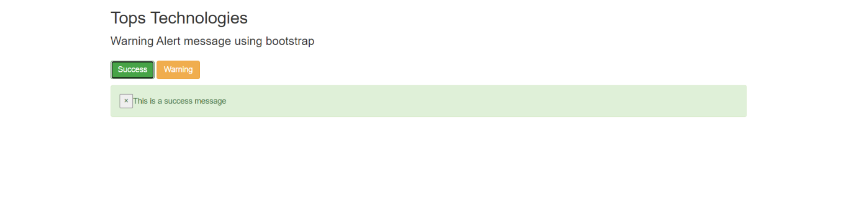

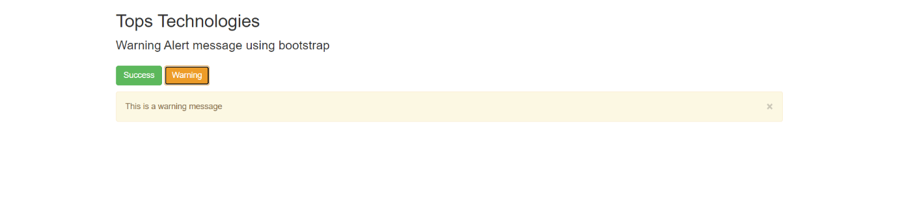

**10.What is a bootstrap card and how would you create one?**

**Ans.** <!DOCTYPE html>

<html lang="en">

<head>

    <meta charset="UTF-8">

    <meta http-equiv="X-UA-Compatible" content="IE=edge">

    <meta name="viewport" content="width=device-width, initial-scale=1.0">

    <title>Document</title>

    <link href="https://cdn.jsdelivr.net/npm/bootstrap@5.0.2/dist/css/bootstrap.min.css" rel="stylesheet" integrity="sha384-EVSTQN3/azprG1Anm3QDgpJLIm9Nao0Yz1ztcQTwFspd3yD65VohhpuuCOmLASjC" crossorigin="anonymous">

    <script src="https://cdn.jsdelivr.net/npm/@popperjs/core@2.9.2/dist/umd/popper.min.js" integrity="sha384-IQsoLXl5PILFhosVNubq5LC7Qb9DXgDA9i+tQ8Zj3iwWAwPtgFTxbJ8NT4GN1R8p" crossorigin="anonymous"></script>

<script src="https://cdn.jsdelivr.net/npm/bootstrap@5.0.2/dist/js/bootstrap.min.js" integrity="sha384-cVKIPhGWiC2Al4u+LWgxfKTRIcfu0JTxR+EQDz/bgldoEyl4H0zUF0QKbrJ0EcQF" crossorigin="anonymous"></script>

</head>

<body>

    <div class="card" style="width: 18rem;">

        <img src="https://images.moneycontrol.com/static-mcnews/2020/03/Ratan-Tata-HOB-3.jpg?impolicy=website&width=1600&height=900" class="card-img-top" alt="...">

        <div class="card-body">

          <h5 class="card-title">Ratan Tata</h5>

          <p class="card-text">Some quick example text to build on the card title and make up the bulk of the card's content.</p>

          <a href="#" class="btn btn-primary">Go somewhere</a>

        </div>

      </div>

</body>

</html>

**Output:-**

